|  |
| --- |
| **Request for Quotation** |

|  |  |
| --- | --- |
| **FROM** | **NORWEGIAN REFUGEE COUNCIL** |
| Address | Hay El Matar, Port Sudan, Sudan |
| City | Port Sudan |
| Country | Sudan |
| Phone # | +249 904219736 |
| Email | sd.procurement@nrc.no [fatima.ismail@nrc.no](mailto:fatima.ismail@nrc.no) [noon.abdalla@nrc.no](mailto:noon.abdalla@nrc.no) |

|  |  |
| --- | --- |
| **TO** |  |
| Address |  |
| City |  |
| Country |  |
| Phone # |  |
| Email |  |
| Company Name |  |

The office of the Norwegian Refugee Council invites your company to submit a price quotation for the following items in accordance with the requirements detailed below. You may use your company format, or fill up the table below. Please read carefully the instructions on page 2.

|  |  |  |  |
| --- | --- | --- | --- |
| **Request for Quotation Requirements** | | | |
| RFQ # : | PF-PS-091 | Currency | USD - EUR |
| RFQ Issuing Date: | 10 th- Octoberr 2024 | Bid Validity Period (days): | Preferably 30 days |
| RFQ Closing Date: **Extension** | 21st of October 2024 | Required Delivery Date: | October 18, 2024 |
| RFQ Closing Time: | **02:00 PM (GMT +2)** | Required Delivery Destination: | Hay El Matar, Port Sudan, Sudan |
| Questions to the RFQ | [sd.procurement@nrc.no](https://norwegianrefugeecouncil.sharepoint.com/sites/sd-nrc-team-site-logistics/Shared%20Documents/KRT%20CO/Procurement/PROCUREMENT%20FILES/PF-KRT-862%20-%20Furniture%20PS/sd.procurement@nrc.no)  fatima.ismail[@nrc.no](mailto:nuseraldeen.eisa@nrc.no) | Required Delivery Terms: | DAP – Including Installation |

|  |  |  |  |  |  |
| --- | --- | --- | --- | --- | --- |
| **To be filled by NRC** | | | | **To be filled by Supplier** | |
| **Item**  **#** | **Description/ Specifications** | **Unit** | **Quantity Required** | **Unit Price** | **Total Price** |
| 1 | Bed + mattresses+ pillows+ bed cover (blanket ) side table with drawer King size bed + mattresses + 2 pillows | Piece | 12 |  |  |
| 2 | Wardrobe | Piece | 12 |  |  |
| 3 | Dressing table with chair | Piece | 12 |  |  |
| 4 | Dining table with 6chairs | Piece | 4 |  |  |
| 5 | Living room set with Sofa, armchairs, and coffee table | Piece | 4 |  |  |
| 6 | Fridge 150 L | Piece | 4 |  |  |
| 7 | microwave | Piece | 4 |  |  |
| 8 | washing machine – front loader 5 kilos | Piece | 4 |  |  |
| 9 | Gas cooker with oven, gas cylinder and regulator | Piece | 4 |  |  |
| 10 | cooking pots set with a frying pan | set | 4 |  |  |
| 11 | Cloth Iron | Piece | 4 |  |  |
| 12 | Ironing Board | Piece | 4 |  |  |
| 13 | Blender | Set | 4 |  |  |
| 14 | Cloth Dryer | Piece | 4 |  |  |
| **GRAND TOTAL (Including Transport and VAT)** | | | | |  |
|  | | | | |  |

|  |  |
| --- | --- |
| Delivery Lead Time (in days, from receipt of NRC Purchase Order) |  |
| Bid Validity Period (in days from receipt of NRC Purchase Order): |  |
| Defects liability and guarantee period: |  |
| What Kind of Support or warranty will be provided |  |
| Please Provide Copies of relevant PO / Contracts |  |
| Country of origin of the goods |  |

|  |  |
| --- | --- |
| Name |  |
| Position |  |
| Date Signature  Stamp |  |

### Evaluation Criteria and Scoring Table

| **Criteria** | **Weight (%)** |
| --- | --- |
| **Quality - Compliance with Specifications** | 30 |
| **Price** | 30 |
| **Delivery Time** | 20 |
| **Experience and Reputation** | 10 |
| **Support and Warranty** | 10 |
| **Total Score** | 100 |

cloth dryer

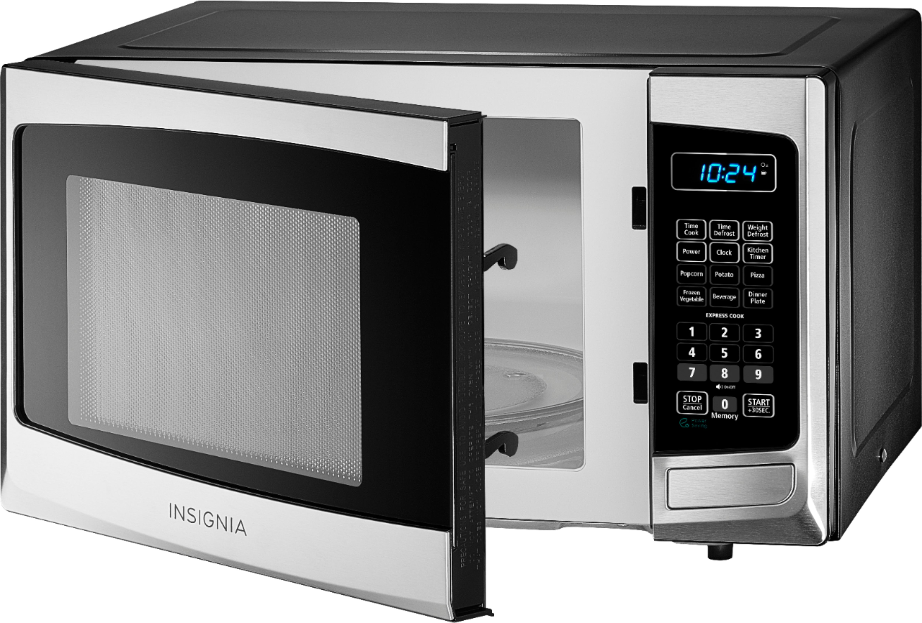

microwave

fridge 14 feet

**Dining table with 6 chairs**

d **Dressing table**

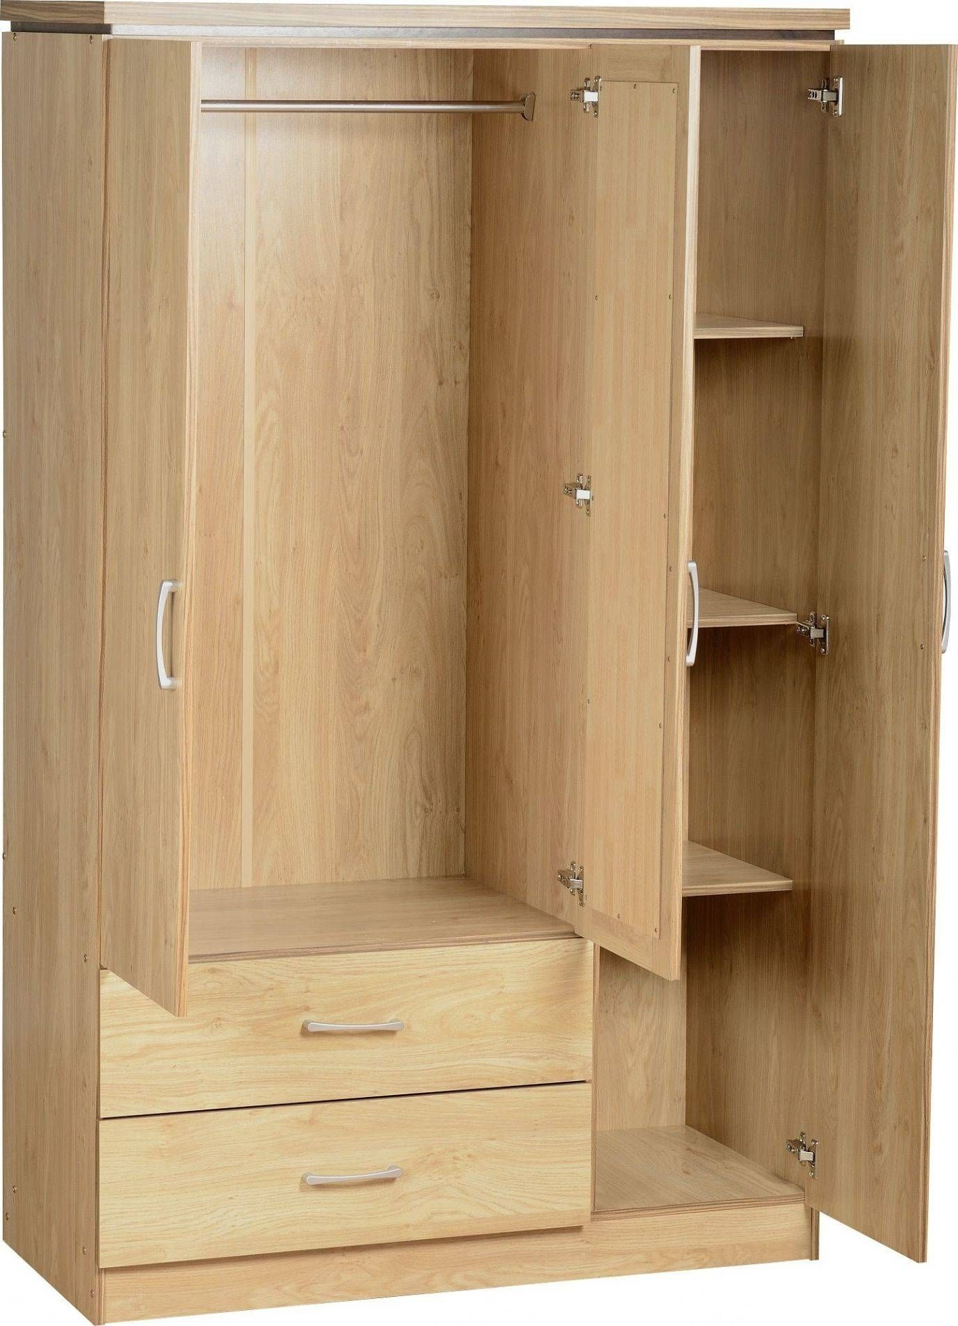

king-size bed **wardrobe**

**washing machine Gas cooker with oven**

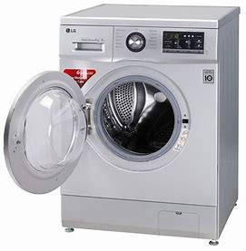

**Cooking pots set**

**Ironing machine**

**ironing board**

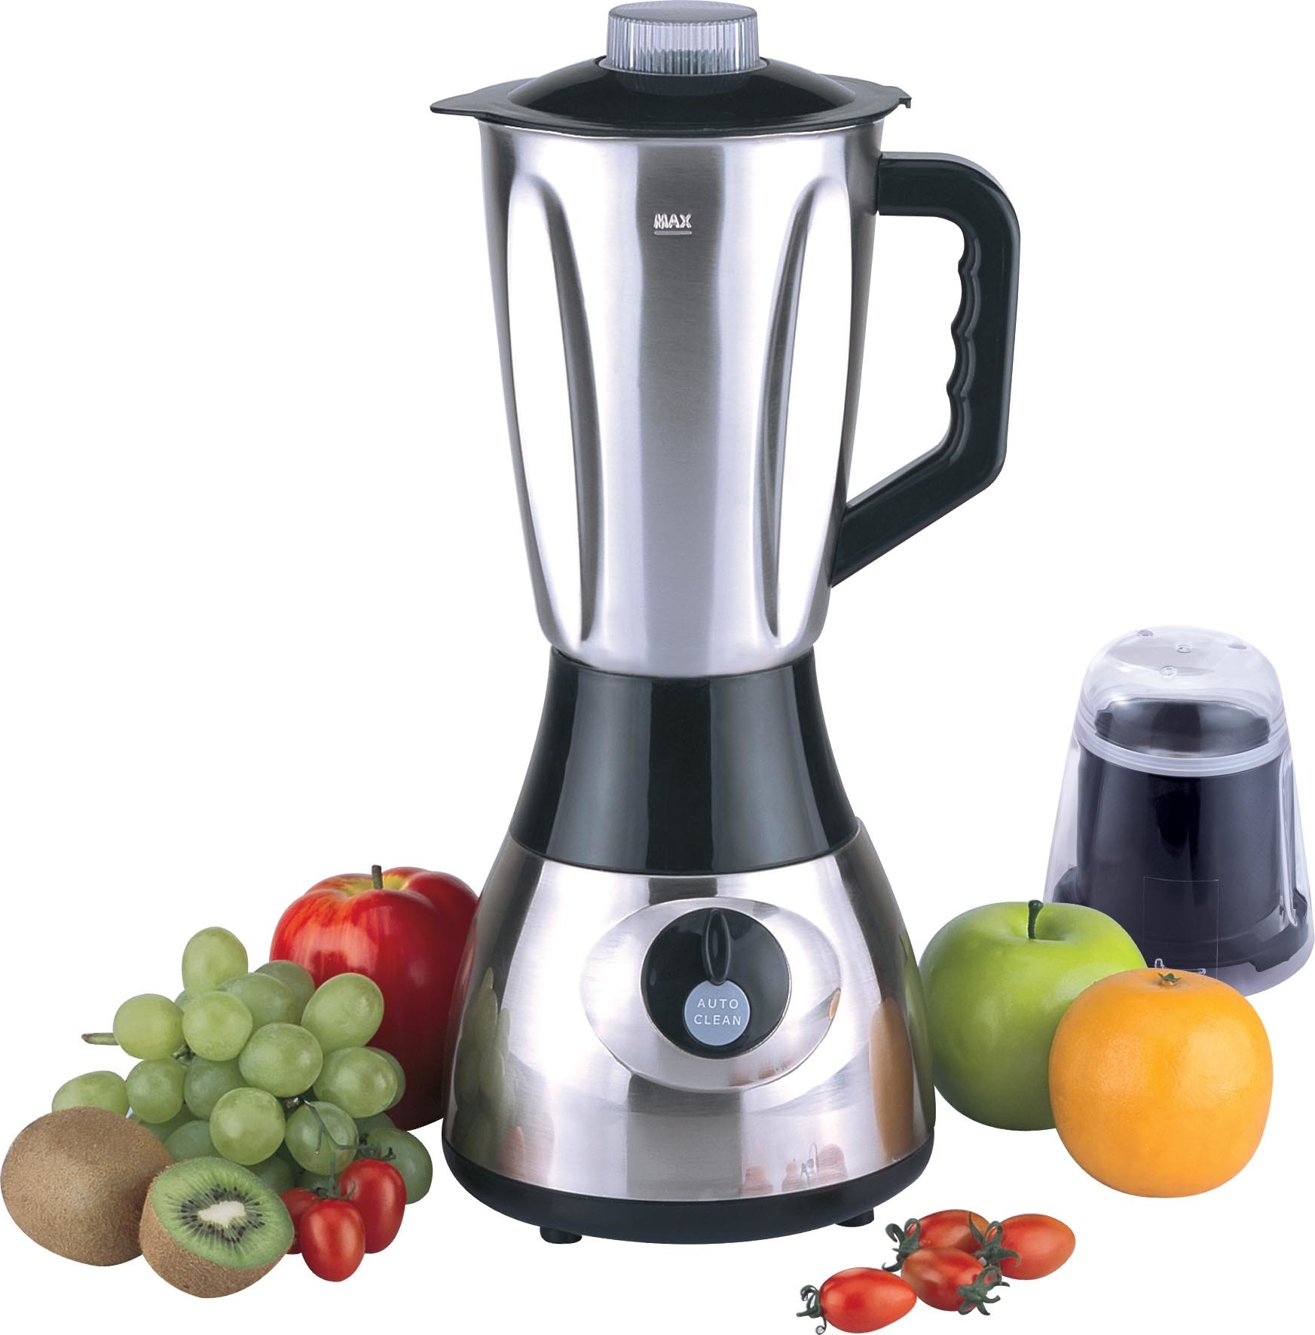 **blender**

**RFQ Terms & Conditions**

**Manner of Submission:**

* By hand in a sealed envelope to the NRC office located, in Hay-Almattar District , Red Sea State, Sudan
* By email to the dedicated and secured email address: sd.procurement@nrc.no (offers received on other email addresses will not be considered)
* Before the Closing date & Time mentioned above. Companies who do not submit their quotation by this deadline will not be considered

**Requirements:**

* All Bids must include all customs and taxes payable in the country of delivery unless the RFQ specifically requests differently
* Bids must be submitted in the currency indicated in the RFQ. Bids in other currency might not be accepted
* Bids must be valid for the validity period indicated in the RFQ. Bids not meeting this validity period might be disqualified
* All enquires and questions should be addressed to the email given in the RFQ details section. All questions and answers will be shared with all invited suppliers.
* NRC reserves the right to accept or reject the whole or part of your quotation based on the information provided. Incomplete quotations which do not comply with our conditions will not be considered.
* Provide Samples for the items listed in annex, together with your offer (if relevant)

**Mandatory documents:**

|  |  |
| --- | --- |
| Requested document | **Check (Y/N)** |
| Company registration Certificate |  |
| Vat Registration Certificate |  |
| Tax registration certificate |  |
| Passport Copy / ID of company director |  |
| Copies of relevant Experience for procurement of furniture |  |
| NRC RFQ to be signed and stamped in each page |  |
| Technical Specification (Catalogue or Picture of each Item) Photos of offered items by supplier– **NRC will contact considered bidders to examine and inspect items in this RFQ according to attached photos and prior PO signature** |  |
| Ethical Standards Signed and Stamped |  |

**Assessment Criteria:**

* All bids received and accepted will be evaluated based on the following:
* Step 1: Administrative compliance check: Each bid will be checked to ensure compliance with all the RFQ requirements
* Step 2: Technical Evaluation: All bids will be technically evaluated based on “best value for money”
* Step 3: Financial Evaluation: Price in comparison to NRC established expectation and in comparison, to other bidders of comparable technical quality

**Payment terms:**

* Payment will be made within 30 days of receipt of goods, by bank transfer/cheque only.

|  |  |
| --- | --- |
|  |  |

|  |  |
| --- | --- |
| NRC is obliged to ensure that its procurement decisions are clearly justified and documented and keeping within the Donors mandatory principles. In that regard, full and on-the-spot access must be granted to representatives of NRC, the Donor or any organisation or person mandated by it, to premises belonging to NRC or its contractors. The right to access shall include all documents and information necessary to assess, or audit the implementation of the contract.  NRC also expects suppliers who process personal data to comply with the General Data Protection Regulation (EU GDPR) and any relevant national legislation.  Suppliers processing personal data on an NRC contract will be required to sign a data processing / sharing agreement as part of the contract.  Refusal to sign such an agreement constitutes refusal of the contract terms and forfeiture of the contract on the part of the supplier.  If the activities of the contract take place in areas with Explosive Hazards, NRC accepts no liability for injury and/or death to contractor’s staff or damage to contractor’s property. | Anti-money laundering, anti-bribery, anti-corruption and anti-terrorism legislation and donor regulations require NRC to screen contractors against various international lists to ensure due diligence.  Submission of the quotation constitutes acceptance of these screening practices.  NRC aims to purchase products and services with minimum environmental impact. Environmental considerations form part of the NRC selection criteria, and NRC reserves the right to reject quotations provided by suppliers not meeting these standards.  All suppliers doing business with NRC should maintain high standards on ethical and environmental issues, respect and apply basic human and social rights, ensure non-exploitation of child labour, and give fair working conditions to their staff. **Suppliers will be required to sign and submit an Ethical Standards Declaration, together with their bid**.  NRC reserves the right to reject quotations provided by suppliers not meeting these standards. |

***Signature & Stamp***